TimEx User’s Manual

V2.02

Coenrad Fourie

03 April 2018

Copyright © 2016-2018 by Coenrad Fourie

Permission is granted to anyone to make or distribute verbatim copies of this document as received, in any medium, provided that the copyright notice and the permission notice are preserved, and that the distributor grants the recipient permission for further redistribution as permitted by this notice.

Linux is a registered trademark of Linus Torvalds.

Ubuntu is a registered trademark of Canonical Ltd.

Windows is a registered trademark of Microsoft Corporation.

All other trademarks are the property of their respective owners.

This work was supported by the Office of the Director of National Intelligence (ODNI), Intelligence Advanced Research Projects Activity (IARPA), via the U.S. Army Research Office grant W911NF-17-1-0120. The views and conclusions contained herein are those of the authors and should not be interpreted as necessarily representing the official policies or endorsements, either expressed or implied, of the ODNI, IARPA, or the U.S. Government. The U.S. Government is authorized to reproduce and distribute reprints for Governmental purposes notwithstanding any copyright notation herein.

**Table of Contents**

[Introduction and setup 4](#_Toc508621059)

[Introduction 4](#_Toc508621060)

[Initial setup 4](#_Toc508621061)

[License 5](#_Toc508621062)

[Building the source code under Windows 5](#_Toc508621063)

[Building the source code under Linux 5](#_Toc508621064)

[Install freepascal and lazarus under CentOS7 Linux 5](#_Toc508621065)

[Install freepascal and lazarus under Ubuntu Linux 6](#_Toc508621066)

[Build TimEx 6](#_Toc508621067)

[Installation under Windows 7](#_Toc508621068)

[Technical discussion 8](#_Toc508621069)

[Cycle identification and flux calculation 8](#_Toc508621070)

[Pulse detection 8](#_Toc508621071)

[Input files 11](#_Toc508621072)

[Definition file 11](#_Toc508621073)

[DUT netlist file 13](#_Toc508621074)

[Functions 14](#_Toc508621075)

[Command line parameters / switches 15](#_Toc508621076)

[Output files 16](#_Toc508621077)

[Verilog model 16](#_Toc508621078)

[Mealy finite state machine representation 18](#_Toc508621079)

[Examples 19](#_Toc508621080)

[Extraction of an RSFQ OR gate 19](#_Toc508621081)

[Bias sweep of RSFQ JTL 22](#_Toc508621082)

[Process tolerance and noise 24](#_Toc508621083)

[Limitations and restrictions 26](#_Toc508621084)

[Errors and exception handling 27](#_Toc508621085)

[References 28](#_Toc508621086)

# Introduction and setup

## Introduction

*TimEx* was developed under IARPA contracts FA8750-15-C-0203-IARPA-BAA-14-03 and SuperTools/ColdFlux (via the U.S. Army Research Office grant W911NF-17-1-0120), and is based on the research described in [1].

*TimEx* takes a JSIM deck file as the first command line parameter and considers this as the Device-Under-Test (DUT). The DUT needs to be described as a subcircuit in the deck file, and input and output ports must be specified. *TimEx* then constructs a simulation test bench consisting of specified load cells at each input and output as well as specified source and sink cells. This is illustrated in Figure 1.

Through the variation of input sequences, all states and all input-to-output delays for the DUT are found. Critical Timing parameters and illegal inputs are then identified through iterative methods, and a Verilog model of the DUT is constructed that defines all states, output delay times and critical timing parameters. A Verilog test bench is also created to verify the operation of the DUT model.

*TimEx* also writes a .gv file (the DOT format) for viewing a Mealy Finite State Machine diagram of the DUT with *GraphViz*.



Figure : Schematic diagram to describe test bench setup around the Device-Under-Test in Timex.

## Initial setup

*TimEx* is a console application, and requires no setup. The executable or binary files can be placed in any directory (accessible with path), while project files can be placed in a working directory.

*TimEx* relies on the light-weight superconducting circuit simulator *JSIM\_n* to perform transient electrical simulations. Make sure that *JSIM\_n* is in a folder on the path.

If *TimEx* is executed with the “-x” switch, you also need to have *iverilog*, *vvp* and *dot* (*GraphViz*) stored in a folder on the path.

Under MS Windows, the executables for *iverilog, vvp* and *jsim\_n* are provided. You can install *dot* from the Graphviz website, [www.graphviz.org](http://www.graphviz.org)

For Linux, the binaries for *JSIM\_n* and *TimEx* are provided. Install the other components (*iverilog*, *vvp* and *dot*) with:

$ sudo apt install iverilog

$ sudo apt install graphviz

This was tested under CentOS7 and Ubuntu 16.04 LTS (Xenial Xerus).

## License

*TimEx* v2 is free to distribute and/or modify under the terms of the MIT license.

## Building the source code under Windows

Under Windows, open the file TimEx.dproj in the directory src with Embarcadero Delphi (this was tested with Delphi XE 5 and Rad Studio 10.1 Berlin).

In the Project Manager window (upper right in Figure 2), select the Release build configuration, and 32-bit Windows as the target platform.

The project can then be built from the Project menu. The binary files will be placed in bin\Win32\Release.

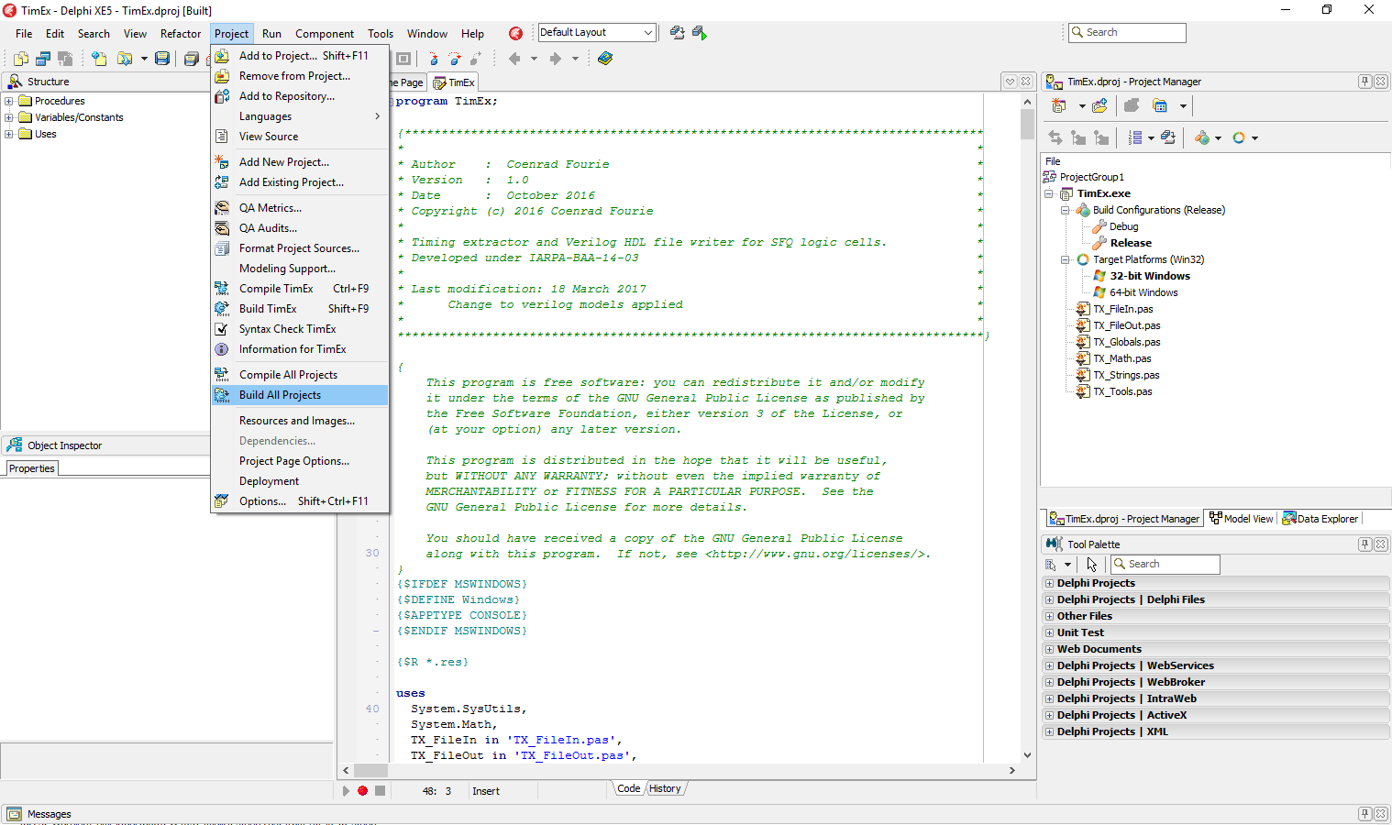

Figure : Building TimEx in Embarcadero Delphi XE5

The 64-bit executable for Windows is provided with the project files, under bin\Win64\Release.

## Building the source code under Linux

### Install freepascal and lazarus under CentOS7 Linux

Under CentOS7 Linux, the *freepascal* compiler and *lazarus* IDE need to be installed. From a web browser, access <https://sourceforge.net/projects/lazarus/files/>. Download the latest RPM files, which should be in the directory *Lazarus Linux x86\_64 RPM* for a 64-bit Intel system. Download the *fpc*, *fpc-src* and *lazarus* packages.

Install these with:

$ sudo yum install gtk2-devel

$ sudo rpm –Uvh \*.rpm

### Install freepascal and lazarus under Ubuntu Linux

Under Linux Ubuntu, *freepascal* and *lazarus* can be installed from the terminal directly with:

$ sudo apt-get install fp-compiler

$ sudo apt-get install lazarus

### Build TimEx

Open the *TimEx* project file with *lazarus*, as shown in Figure 3.

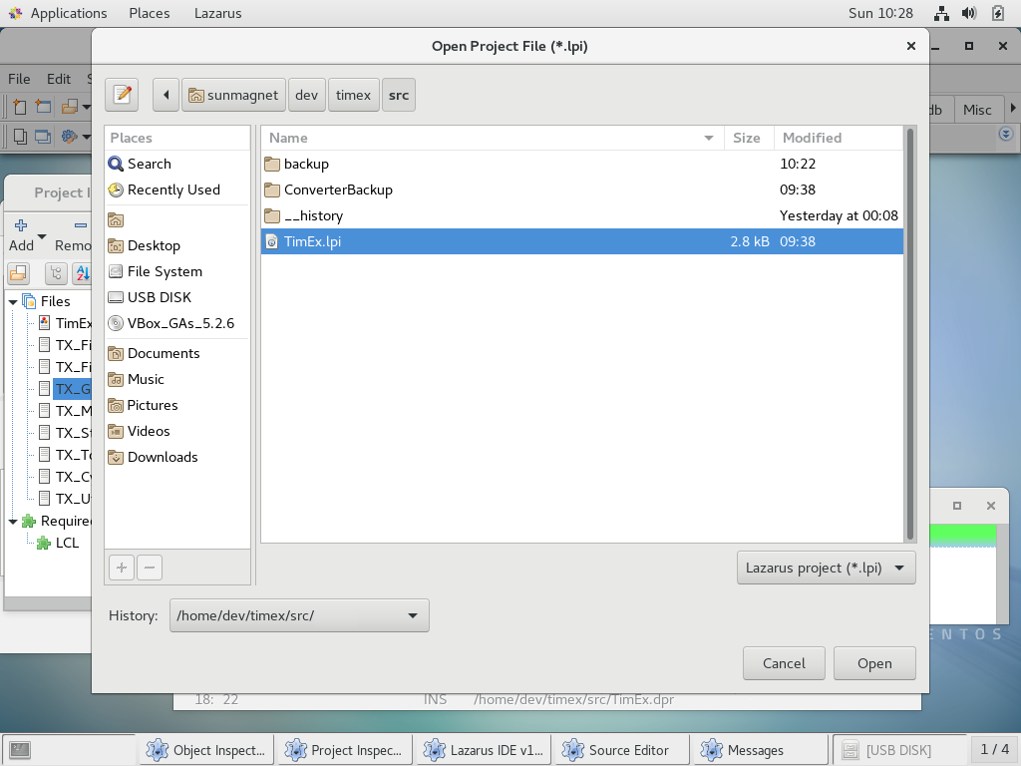

Figure : Opening the TimEx project file in lazarus under CentOS7 Linux.

Select build, as shown in Figure 4 to build the source code.

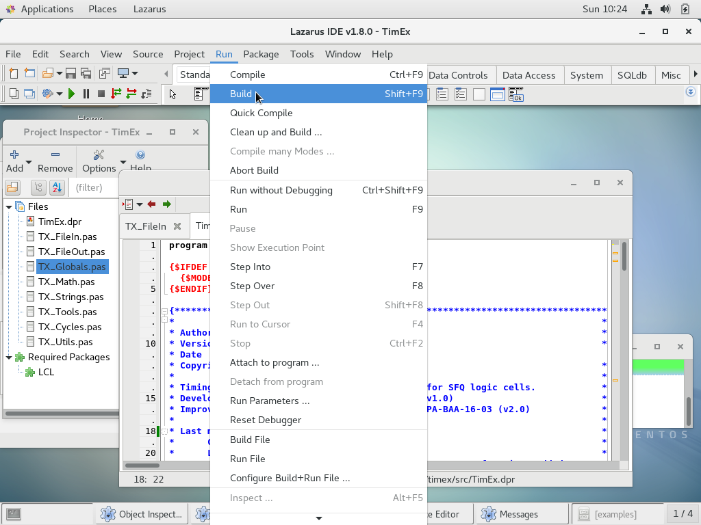

Figure : Building TimEx in lazarus under CentOS7 Linux.

## Installation under Windows

In order to use *TimEx* fully, install the following components:

1. Download *Icarus Verilog* from http://bleyer.org/icarus/ and install.
2. Download *Graphviz* from <http://www.graphviz.org/> and install:
3. Add the following directories to the system PATH variable:

<TimEx\_INSTALL\_DIR>\bin\win

<Icarus Verilog\_INSTALL\_DIR>\bin

<Icarus Verilog\_INSTALL\_DIR>\gtkwave\bin

<Graphviz\_INSTALL\_DIR>\bin

where, <X\_INSTALL\_DIR> is the directory where X has been installed.

# Technical discussion

## Cycle identification and flux calculation

For the state of a cell to be investigated, the flux in every cycle (or loop / mesh) in the circuit must be evaluated as

 (1)

where *In* is the signed branch current and *Ln* is the branch inductance. The flux is expected to be -1, 0 or 1 times the magnetic flux quantum (Φ0). An algorithm thus finds all the meshes in the circuit so that cycle flux can be calculated from the sum of branch currents multiplied by element inductances. For Josephson junctions, the total equivalent inductance *LJt* is used [2], where

 (2)

and

. (3)

Resistive cycles do not store flux, so that any cycles that contain resistors are ignored. *TimEx* also disregards cycles that contain any input or output ports, as the assumption is that flux storage in the interconnect inductance between any load and input/output of the DUT represents unacceptable circuit behaviour.

Numerical errors and errors in the Josephson inductances lead to cycle flux results that are spread over the range of roughly 0.98Φ0 to 1.02Φ0. In the current version, *TimEx* then divides the cycle flux results by Φ0 and rounds the values to the nearest integer (-1, 0 or 1), with the sign depending on the direction of flux through a cycle.

## Pulse detection

Even though analyses of time-based electrical simulations of SFQ circuits mostly rely on the phase evolution over Josephson junctions, *TimEx* investigates the voltage pulses at the inputs and outputs of the DUT. This is necessitated by the Verilog descriptions, which require response to the arrival of signals at the DUT inputs (which are typically inductors) and for which signal arrival times at the outputs need to be specified.

A simple way to detect pulses is to look for the peak values in voltage vs time plots, but this is risky. Firstly, a cell might fail to switch correctly and just create a ripple in the output of which peaks might be mistaken for pulses. Secondly, measurement of the pulses between the inductances of inputs/outputs to/from a load and the DUT often results in pulses that seem to oscillate, so that the peak value could shift by a few picoseconds depending on the inductances.

The voltage pulses transmitted between SFQ elements integrate to exactly one fluxon, so that a much more reliable way of detecting a pulse is to use a sliding numerical integrator (see Figure 5 [2].) When the area inside the sliding integrator is compared to a threshold (set as a fraction of Φ0), the time at which the threshold is passed is a very stable way to characterise pulse arrival time.

In *TimEx*, the parameters SlidingIntegratorLength and PulseDetectThreshold set the length of the sliding integrator window (in time) and the integrated area threshold as a fraction of Φ0 for pulse detection respectively.



Figure : Pulse detection in *TimEx* with a sliding voltage-time integrator.

When pulses are transmitted over passive transmission line interconnects, the resistance in series with the PTL elements results in pulse areas lower than Φ0. In order to accommodate this, the minimum area for a successful pulse to be detected can be defined with the parameter PulseFluxonFraction. Such a reduced size output pulse can be seen in Figure 6(c) [2].

pulseplot_multiple_gates

Figure : SFQ output pulses of (a) a JTL into a JTL load, (b) an RFSQ XOR gate into a JTL load and (c) an RSFQ DFF cell with integrated PTL driver into a matched transmission line (solid lines). Calculation results of a sliding window integrator with a window length of 12.5 ps are also shown (dashed lines).

# Input files

## Definition file

*TimEx* is configured and controlled through a definition file that can have any name.

The definition file defines parameters and optional load, sink or source netlists in demarcated blocks.

Table 1 shows the parameters available in the definition file, and what these control. The parameters are defined inside a control block starting with

$Parameters

and ending with

$End

Parameters are defined as:

Parametername = value

Table : Definition file parameters.

| Parameter name | Default value | Function |
| --- | --- | --- |
| CTDependencyThreshold | 0.1E-12 | Minimum binary search threshold for timing dependency between inputs. If a smaller critical timing dependency exists, it will be ignored. |
| InputChainDelay | 7E-12 | If the “-x” switch is used, a *jsim* simulation deck file is constructed with InputChainDelay subtracted from the time at which all inputs are applied. This accounts for the delay from the source element through the input load to the input of the DUT. |
| IOFullFluxon | true | Set true if pulses are full fluxons (all interconnects made with superconducting lines with no resistance). |
| MaxDelayChange | 1E-12 | The maximum time that the delay between an input and it’s corresponding output may shift from nominal when critical timing is approached. Beyond this, an error condition is flagged. |
| MinSameInputSeparation | 5E-12 | The minimum time between separate pulses applied by the test bench to the same input when IOFullFluxon is false. |
| NoiseTemperature | -1 | The temperature at which noise spectral amplitude is calculated for resistors for noise simulations. At zero and below, noise analysis is ignored. |
| NumberSimsTolerance | 0 | The number of simulations with randomly distributed values and optional noise current sources from which the worst-case, mean and standard deviation of delay timing parameters are calculated. For values below 2, random variables and noise are ignored. |
| PulseDetectThreshold | 0.5 | The integration threshold (as a fraction of Φ0) that indicates a detected pulse in a voltage-time curve. |
| PulseFluxonFraction | 0.9 | Minimum integration area (as a fraction of Φ0) required to validate an SFQ pulse. |
| SimTimeStep | 0.25E-12 | Time step for JSIM transient simulations. |
| SlidingIntegratorLength | 10E-12 | The time length of the sliding window over which ∫*v⋅dt* is calculated to search for pulses. |
| SourceAmplitude | - | Amplitude of triangular input pulse at source element. |
| SourceFallTime | - | Fall time of triangular input pulse at source element. |
| SourceRiseTime | - | Rise time of triangular input pulse at source element. |
| SourceType | current | Source element type (current source or voltage source). Options are “current” and “voltage”. |
| TimeFirstStable | 10E-12 | Time at which startup state is investigated in *jsim* simulation. |
| VerilogStableTime | 10E-12 | Time to first input in startup state for the Verilog test bench simulation model. |
| VerilogWaitTime | 10E-12 | Time between inputs for the Verilog test bench simulation model. |
| WaitForStateChange | 50E-12 | Time between inputs when state response to inputs are evaluated in *jsim*. |

The definition file can contain optional definitions for the default source, load and sink netlist decks. These are loaded first, and can be replaced with optional netlist decks specified in the command line when *TimEx* is called.

The default input load (through which a pulse from a source is fed to an input in the DUT) must be a valid subcircuit and specified in a block starting with

$DefaultLoadIn

and ending with

$End

The default output load, which is connected to every output of the DUT, must be a valid subcircuit and specified in a block starting with

$DefaultLoadOut

The block is also terminated with the $End line.

The sink and source definition blocks are defined similarly, except for the block identifiers which are $DefaultSource and $DefaultSink respectively.

All netlist cards (lines) need to be less than 256 characters in length (the rest is truncated), and *TimEx* does not yet support line carry-over with the “+” identifier.

The definition file can also contain a control block, starting with

$Control

and ending with

$End

The sweep control is used to extract timing parameters that are functions of parameter variation. As an example, the bias of a DUT can be swept with the control

Sweep *variablename* *startvalue incrementvalue stopvalue*

This requires a variable named *variablename* to be defined in the DUT netlist file.

Examples are:

SWEEP bias 0.5 0.1 2.0

Although it is possible to specify multiple variables and multiple sweeps, the current version of *TimEx* only executes the first sweep in a netlist. This limit stems from the difficulty in setting up equations for timing parameters based on multiple parameters without incurring very long simulation times.

## DUT netlist file

The DUT netlist file must be in the form of a subcircuit (with no components outside of the .SUBCKT to .ENDS block.

Very importantly, the netlist **must contain** a port definition card (anywhere in the file) of the form:

\*$Ports in\_anyname in\_anyothername out\_yetanothername

where

\* identifies the card as a comment to *jsim*.

$Ports identifies the card as the port definition command to *TimEx*.

in\_ is the input identifier. Any text directly following it represents the input name.

out\_ is an output identifier. The output name follows directly.

All input and output names must be unique, but can have any order. The limit is set by the card length of 255 characters.

If a variable is swept, that variable must be declared as a parameter in the netlist:

.PARAM *variablename*=*nominalvalue*

The nominal value of a variable is the value that it is assigned when the nominal circuit is analysed to find all the states and state transitions. The variable name is not case sensitive.

A variable is invoked in the netlist by placing it inside braces. Expressions are evaluated.

For example:

IB1 0 3 pwl(0 0 5p {Bias\*350e-6})

If Bias has a nominal value of 1.0, the bias current is nominally 350 μA. With the same variable, a bias voltage of 2.5 mV can be applied as:

VB1 4 0 pwl(0 0 5p {@Bias\*2.5e-3})

## Functions

Netlist files may contain functions in expressions. These functions are evaluated by *TimEx* before a netlist is sent to JSIM. Currently only the following functions are supported:

GAUSS(*mean*, *stddev*)

This function calculates a normally distributed random variable (real) with mean *mean* and standard deviation *stddev*.

# Command line parameters / switches

*TimEx* uses command line parameters and switches.

The first command line parameter must be the DUT subcircuit netlist file in *jsim* format.

Other parameters or switches can be supplied in any order.

-d filename – specifies the name of the *jsim* netlist file for the DUT subcircuit.

-e filename – name of the optional *jsim* netlist file for the source subcircuit.

-L filename – name of the optional *jsim* netlist file for the input load subcircuit.

-l filename – name of the optional *jsim* netlist file for the output load subcircuit.

-o filename – name of the optional text file to which the state map is written. The default name is statemap.txt.

-s filename – name of the optional *jsim* netlist file for the sink subcircuit.

-v – switch on verbose mode.

-x – Instructs *TimEx* to execute *jsim\_n* on the simulation test bench for the DUT and write the output to a .dat file, execute *iverilog* and *vvp* on the Verilog test bench for the extracted HDL model of the DUT, and execute *dot* on the graph description (.gv file) for the Mealy FSM diagram of the DUT.

# Output files

## Verilog model

*TimEx* creates a Verilog .v file from the characteristics extracted for the DUT, and places it in the working directory.

The input and output names match those specified in the DUT netlist with the \*$Ports command.

A real variable section is defined that contains all the timing values for easy lookup. Naming convention is standardised to allow automated readout by a suitably modified Static Timing Analysis tool.

The real variables are defined as:

type\_statenr\_terminal1\_terminal2

where

type = {delay | ct} (in-to-out delay time | critical timing)

statenr = the number of the state in sequence of extraction, with 0 always the startup state

terminal1 = the name of an input

terminal2 = the name of an output (for delay timing) or another input (for critical timing.)

Timing values are in picoseconds, and represent either the delay from the arrival of an input pulse to the appearance of a corresponding output pulse (delay) or the critical timing value (minimum allowable separation) between an input and another input.

If a timing error or an illegal state is detected, all the outputs are changed to undefined.

An example is shown in Figure 7.

timescale 1ps/100fs

module mitll\_dff (set, reset, out);

input

set, re;

output

out;

reg

out;

real

delay\_state1\_reset\_out = 5.0,

ct\_state0\_reset\_set = 0.2,

ct\_state1\_reset\_set = 1.0;

reg

errorsignal\_set,

errorsignal\_reset;

integer

outfile,

cell\_state; // internal state of the cell

initial

begin

errorsignal\_set = 0;

errorsignal\_reset = 0;

cell\_state = 0; // Startup state

out = 0; // All outputs start at 0

end

always @(posedge set or negedge set) // execute at pos and neg edges of input

begin

if ($time>4) // arbitrary steady-state time)

begin

if (errorsignal\_set == 1'b1) // A critical timing is active for this input

begin

outfile = $fopen("errors.txt", "a");

$fdisplay(outfile, "Violation of CT in module %m; %0d ps.\n", $stime);

$fclose(outfile);

out <= 1'bX; // Set all outputs to unknown

end

if (errorsignal\_set == 0)

begin

case (cell\_state)

0: begin

cell\_state = 1; // Blocking statement -- immediately

end

endcase

end

end

end

always @(posedge reset or negedge reset) // execute at pos and neg edges of input

begin

if ($time>4) // arbitrary steady-state time)

begin

if (errorsignal\_clk == 1'b1) // A critical timing is active for this input

begin

outfile = $fopen("errors.txt", "a");

$fdisplay(outfile, "Violation of CT in module %m; %0d ps.\n", $stime);

$fclose(outfile);

out <= 1'bX; // Set all outputs to unknown

end

if (errorsignal\_clk == 0)

begin

case (cell\_state)

0: begin

errorsignal\_set = 1; // Critical timing on this input; assign now

errorsignal\_set <= #(ct\_state0\_reset\_set) 0; // Clear later

end

1: begin

out <= #(delay\_state1\_reset\_out) !out;

cell\_state = 0; // Blocking statement -- immediately

errorsignal\_set = 1; // Critical timing on this input; assign now

errorsignal\_set <= #(ct\_state1\_reset\_set) 0; // Clear later

end

endcase

end

end

end

endmodule

Figure : Functional Verilog model of an RSFQ DFF extracted with TimEx.

## Mealy finite state machine representation

*TimEx* generates Mealy finite state machine diagrams for the cells which are extracted. This can be used to visualise all states and state transitions. A solid circle on a line between state transitions represents an output pulse. Examples are shown in Figure 8.

|  |  |
| --- | --- |
| C:\Users\coenrad\AppData\Local\Microsoft\Windows\INetCache\Content.Word\TimEx_Mealy_DFF.EPS | C:\Users\coenrad\AppData\Local\Microsoft\Windows\INetCache\Content.Word\TimEx_Mealy_DFF_nobuffer.eps |
| (a) | (b) |

Figure : (a) Mealy diagram of an RSFQ DFF with an input buffer junction at SET, and (b) Mealy diagram of an RSFQ DFF without an input buffer junction at SET and an error state resulting from a SET input in State 1.

# Examples

## Extraction of an RSFQ OR gate

A set of examples are included with the *TimEx* distribution package. At the start, this includes a JTL, two DFF circuits (one with an input buffer junction at the SET input, and the other without), an OR gate and an AND gate.

The examples can be executed with the examples/runexamples.bat script under Windows.

Linux examples are packaged in a compressed archive file: examples/linux\_examples.tar.gz. The batch script is runexamples.sh.

Consider the example of an RSFQ OR gate, of which the schematic is shown in Figure 9.

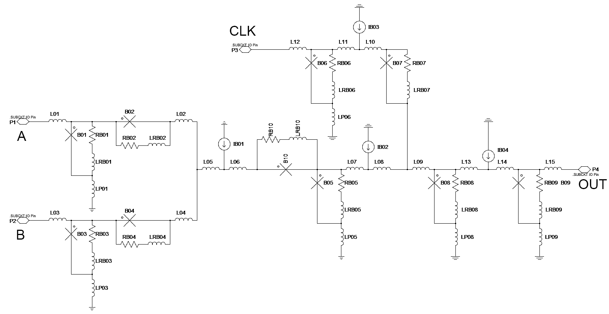

Figure : RSFQ OR gate schematic.

When *TimEx* is executed on the netlist file, the result is:

C:\usr\local\bin\examples>TimEx .\mitll\_or\mitll\_or.js –d .\definitions\definitions\_niobias.txt -x

TimEx v2.02.00 (10 Mar 2018). Copyright 2016-2018 Coenrad Fourie, Stellenbosch University

This program comes with ABSOLUTELY NOE WARRANTY.

Definition file read.

Deck for Device-Under-Test read.

Finding all cycles.

Cycles:

[lp06,-b06,l11,l10,b07,l09,b08,-lp08]

[lp06,-b06,l11,l10,b07,l09,l13,l14,b09,-lp09]

[lp06,-b06,l11,l10,b07,-l08,-l07,b05,lp05]

[lp06,-b06,l11,l10,b07,-l08,-l07,-b10,-l06,-l05,-l02,-b02,b01,lp01]

[lp06,-b06,l11,l10,b07,-l08,-l07,-b10,-l06,-l05,-l04,-b04,b03,lp03]

[-lp01,-b01,b02,l02,-l04,-b04,b03,lp03]

[-lp01,-b01,b02,l02,l05,l06,b10,l07,l08,l09,b08,-lp08]

[-lp01,-b01,b02,l02,l05,l06,b10,l07,l08,l09,l13,l14,b09,-lp09]

[-lp01,-b01,b02,l02,l05,l06,b10,b05,lp05]

[-lp03,-b03,b04,l04,l05,l06,b10,l07,l08,l09,b08,-lp08]

[-lp03,-b03,b04,l04,l05,l06,b10,l07,l08,l09,l13,l14,b09,-lp09]

[-lp03,-b03,b04,l04,l05,l06,b10,b05,lp05]

[-lp05,-b05,l07,l08,l09,b08,-lp08]

[-lp05,-b05,l07,l08,l09,l13,l14,b09,-lp09]

[lp08,-b08,l13,l14,b09,-lp09]

.\mitll\_or\mitll\_or.js: Finding all states.

State 1: Input "clk" -> Output "out" after 7.25E-12 s.

States found: 2

.....State 0: No critical timing found a->a. (5 iterations.)

..........State 0: No critical timing found a->b. (10 iterations.)

.......xxxState 0: Critical timing found a->clk: 1.25E-12 s.

..........State 0: No critical timing found b->a. (10 iterations.)

.....State 0: No critical timing found b->b. (5 iterations.)

.......xxxState 0: Critical timing found b->clk: 1.25E-12 s.

..........State 0: No critical timing found clk->a. (10 iterations.)

..........State 0: No critical timing found clk->b. (10 iterations.)

.....State 0: No critical timing found clk->clk. (5 iterations.)

.....State 1: No critical timing found a->a. (5 iterations.)

..........State 1: No critical timing found a->b. (10 iterations.)

....xx.x.xState 1: Critical timing found a->clk: 4.219E-12 s.

..........State 1: No critical timing found b->a. (10 iterations.)

.....State 1: No critical timing found b->b. (5 iterations.)

....xx.x.xState 1: Critical timing found b->clk: 4.219E-12 s.

..........State 1: No critical timing found clk->a. (10 iterations.)

..........State 1: No critical timing found clk->b. (10 iterations.)

.....State 1: No critical timing found clk->clk. (5 iterations.)

Writing Verilog and testbench files.

Executing testbench simulations.

The cycles are listed. Note that a component such as L08 (first cycle) is connected with its positive node to ground in the netlist file, hence the negative sign in the cycle list.

*TimEx* identifies 2 states, and only one way to generate an output pulse – when an input is applied to “clk” in State 1. The clk->out delay is 7.25 ps. Some critical timing relationships are also found. The Mealy state diagram is shown in Figure 10. Note that an input to “clk” in State 1 results in an output pulse to “out”.



Figure : Mealy diagram extracted for the RSFQ OR gate.

The test bench generated by *TimEx* is simulated in both *jsim* and *iverilog/vvp*, and the results are shown in Figure 11. Note that *TimEx* Verilog models represent an input or output pulse as a low-high or high-low transition, which is easier to view for longer simulations. The pulse positions match, as expected, but note that the *jsim* output pulse “out” integrates to the detection threshold somewhere between its two peaks. Simple “largest peak” detection would lock on to the second peak, causing a timing miscalculation.

The error signals (used to test for critical timing violations) are also shown.

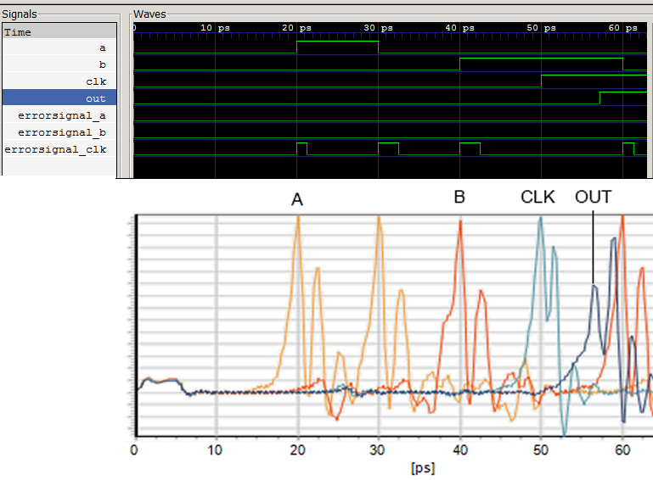

Figure : Verilog (top) and *jsim* (bottom) simulations of the RSFQ OR gate test bench.

If the “clk” input is moved to 1 ps after the first input on “b”, a critical timing violation results in an undefined output at “out”, as shown in Figure 12.

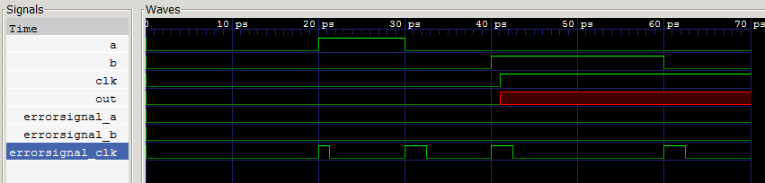

Figure : Verilog simulation of RSFQ OR gate with critical timing violation.

## Bias sweep of RSFQ JTL

The state-dependent timing parameters of RSFQ circuits are influenced by other parameters such as circuit bias level, remanent magnetic field and output loads. In order to incorporate such influences in the Verilog HDL model of an RSFQ cell, TimEx supports swept variables.

Although JSIM does not support SPICE parameter declarations through the .PARAM card, the TimEx preprocessor evaluates .PARAM cards and expressions in the netlist to create compatibility between SPICE and JSIM. In order to allow a sweep of the bias, it must be declared as a parameter with a nominal value.

The use of a swept variable is demonstrated here for a JTL. The netlist file is:

\* Variables

.PARAM bias=2.5

.PARAM Vc = 1.0

\*$Ports in\_in out\_out

.SUBCKT jtl 2 5

B1 1 6 jjmitll100 area=2.5

B2 4 8 jjmitll100 area=2.5

IB1 0 3 pwl(0 0 5p {bias\*1e-3/7.14})

L1 2 1 2p

L2 1 3 2p

L3 3 4 2p

L4 4 5 2p

LB1 7 6 1p

LB2 9 8 1p

Lp1 6 0 0.2p

Lp2 8 0 0.2p

RB1 1 7 {2.74\*Vc}

RB2 4 9 {2.74\*Vc}

.model jjmitll100 jj(rtype=1, vg=2.8mV, cap=0.07pF, r0=160, rn=16, icrit=0.1mA)

.ends jtl

A control block in the definitions file controls the sweep:

$Control

Sweep bias 1.5 0.25 4.5 // Sweep “bias” from 2.5 to 4.5 in steps of 0.25

$End

The resulting Verilog model is:

`timescale 1ps/100fs

module jtl\_vc100 (in, out);

input

in;

output

out;

reg

out;

parameter

bias = 2.5;

real

delay\_state0\_in\_out = 4.0, // Nominal value at bias=2.5

ct\_state0\_in\_in = 3.3; // Nominal value at bias=2.5

reg

errorsignal\_in;

integer

outfile,

cell\_state; // internal state of the cell

initial

begin

errorsignal\_in = 0;

cell\_state = 0; // Startup state

out = 0; // All outputs start at 0

if (bias < 1.5)

begin

out <= 1'bX;

end

if ((bias >= 1.5) && (bias < 1.75))

begin

delay\_state0\_in\_out = 6.0 + (-0.5/0.3)\*(bias-1.5);

ct\_state0\_in\_in = 6.6 + (-3.4/0.3)\*(bias-1.5);

end

if ((bias >= 1.75) && (bias < 2))

begin

delay\_state0\_in\_out = 5.5 + (-0.8/0.3)\*(bias-1.8);

ct\_state0\_in\_in = 3.3 + (0.0/0.3)\*(bias-1.8); // Testbench limit

end

...

if (bias > 4.25)

begin

out <= 1'bX;

end

end

...

The extracted timing delay of JTL as a function of bias voltage and a parameter that sets the junction damping coefficient is shown in Figure 13.

JTL_delay

Figure : Extracted delay of a JTL with nominal *IC* = 250 μA in the MIT Lincoln Laboratory 10 kA/cm2 process as a function of applied bias voltage and characteristic voltage *VC*.

## Process tolerance and noise

The effects of fabrication process tolerances and noise can be included during timing extraction. For process tolerances, both global (wafer-to-wafer and chip-to-chip) variations and local (component-to-component) tolerances can be modelled with random functions. In this version of *TimEx*, only Gaussian random variables are supported.

Process tolerances are added as shown below:

.PARAM bias=1.0

.PARAM globalb={gauss(1,0.03)}

.PARAM globall={gauss(1,0.05)}

.PARAM globali={gauss(1,0.06)}

.PARAM globalr={gauss(1,0.07)}

\*$Ports in\_set in\_reset out\_out

.SUBCKT dff 19 25 23

B1 1 2 jjmitll100 area={2.5\*globalb\*gauss(1,0.05)}

B2 10 16 jjmitll100 area={2\*globalb\*gauss(1,0.05)}

…

IB1 0 20 pwl(0 0 5p {260uA\*bias\*globali\*gauss(1,0.1)})

…

L1 19 1 {2p\*globall\*gauss(1,0.05)}

RB1 1 12 {2.74\*globalr\*gauss(1,0.1)}

…

Here, the global variations are defined with .PARAM, while local variations are assigned when element values are defined.

Noise is added when a non-zero temperature is specified in the definition file.

NoiseTemperature = 4.2

When a noise temperature is specified, *TimEx* adds noise current sources in parallel with all resistors in the DUT.

*TimEx* uses the random variations and thermal noise to calculate delay times, but not critical times. The latter requires too many simulations at present.

The number of simulations from which delay times are calculated, is set by

NumberSimsTolerance = *integervalue*

After completion of all simulations, the worst-case timing values for every delay are written to the Verilog model. Comments at every delay time list the calculated mean and standard deviations (assuming Gaussian distribution) for post-processing. An example result is:

real

delay\_state1\_reset\_out = 6.8, // Mean = 5.198 StdDev = 0.680

ct\_state0\_reset\_set = 0.2,

ct\_state1\_reset\_set = 1.0;

# Limitations and restrictions

Due to the limitations of other software such as JSIM, some restrictions apply to input files for TimEx.

The underscore (‘\_’) character cannot be used in element names, as this breaks the JSIM print command when the element is in a subcircuit.

The Gauss random function does not currently allow expressions, only real numbers. For example, gauss(1,0.1) is valid, but gauss(somevariable\_standard, 0.05\*some\_other\_var) is not allowed.

# Errors and exception handling

The current version of *TimEx* contains basic exception handling that is reasonably robust for file input errors. Halt codes are printed upon exit when obvious errors are detected or exceptions caught. Despite this, some user inputs may cause unhandled exceptions.

To limit unexpected exceptions, always use a definition file that has a default source, sink and load defined (*TimEx* is distributed with a default definition file for RSFQ cells matched to 250 μA JTL loads.) This way, if the source, sink and/or load netlists are not specified in the command line, there are default descriptions in memory.

# References

|  |  |
| --- | --- |
| [1] | L. C. Müller and C. J. Fourie, “Automated state machine and timing characteristic extraction for RSFQ circuits,” *IEEE Trans. Appl. Supercond.,* vol. 24, p. 1300110, 2014. |
| [2] | C. J. Fourie, “Extraction of SFQ circuit Verilog models through flux loop analysis,” *IEEE Trans. Appl. Supercond.,* vol. Submitted for publication. |